**PHP TASK 2(Session and Cookies)**

**1.Create session variables on the first page, and access/update the variables in the next pages and destroy the variables on the last page**

**1.Creating Session variable**

<!DOCTYPE html>

<html>

<head>

<body>

<?php

session_start();

#Creating session variable

$_SESSION['Tournament']="Indian Premier League";

$_SESSION['Teamname']="Chennai super kings";

$_SESSION['Captain']="MS Dhoni";

$_SESSION['Trophies won']="3";

$_SESSION['Coach']='Fleming';

print_r($_SESSION);

?>

</body>

</head>

</html>

**Output:**

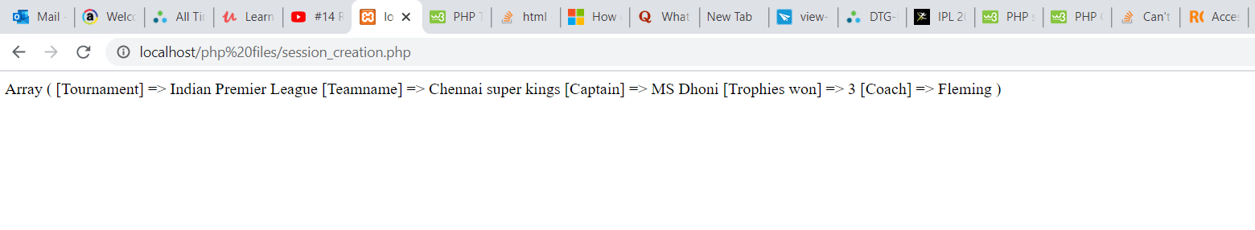

**2.Accessing/updating the session variable**

<!DOCTYPE html>

<html>

<head>

<body>

<?php

session_start();

#Acessing and Updating the values the variables

$_SESSION['Tournament']="Indian Premier League";

$_SESSION['Teamname']="Mumbai indians";

$_SESSION['Captain']="Rohit sharma";

$_SESSION['Trophies won']="3";

$_SESSION['Coach']="Ricky pointing";

print_r($_SESSION);

?>

</body>

</head>

</html>

**Output:**

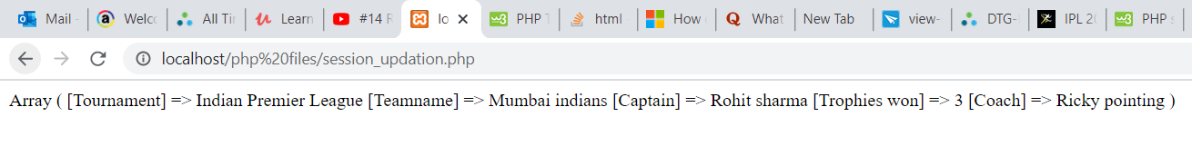

**3.Deleting the session variable**

<!DOCTYPE html>

<html>

<head>

<body>

<?php

session_start();

#Destroying the session variable

session_unset();

print_r($_SESSION);

?>

</body>

</head>

</html>

**Output:**



**2.Create a cookie variable that should be accessible on all the pages and should not be destroyed if the session is closed or the user closes the website.**

<!DOCTYPE html>

<?php

$cookie_name = "Ameex_Technologies";

$cookie_value = "Chennai";

setcookie($cookie_name, $cookie_value, time() + (86400 * 30), "/"); // 86400 = 1 day

?>

<?php

if(!isset($_COOKIE[$cookie_name])) {

echo "Cookie named '" . $cookie_name . "' is not set!";

} else {

echo "Cookie '" . $cookie_name . "' is set!<br>";

echo "Value is: " . $_COOKIE[$cookie_name];

}

?>

<html>

<body>

**Output:**

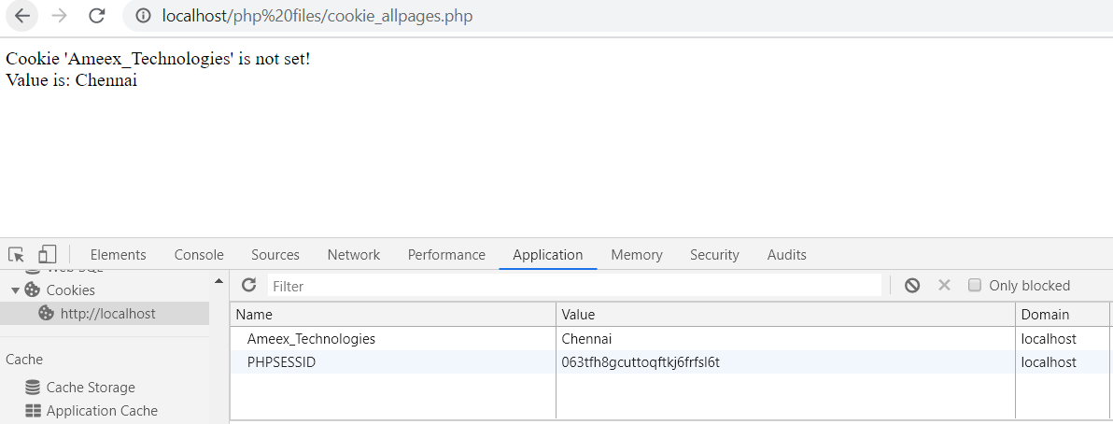

**3.Create a cookie variable that should be accessible on all the pages and should be destroyed if the session is closed or the user closes the website.**

<!DOCTYPE html>

<?php

$cookie_name = "Ameex_Technologies";

$cookie_value = "PHP";

setcookie($cookie_name, $cookie_value, time(), "/"); // 86400 = 1 day

?>

<html>

<body>

**Output:**

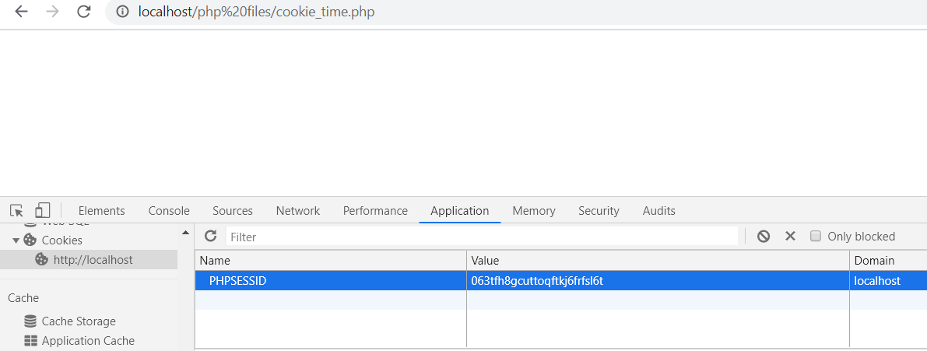

**4.Create a cookie variable that should be accessible on a particular path and its subpath.**

<!DOCTYPE html>

<?php

$cookie_name = "Ameex_Technologies";

$cookie_value = "IIFL";

setcookie($cookie_name, $cookie_value,time() + (86400 * 30), "http://localhost/php%20files/cookie_path.php"); // 86400 = 1 day

echo'Cookie is set successfully';

?>

<html>

<body>

**Output:**

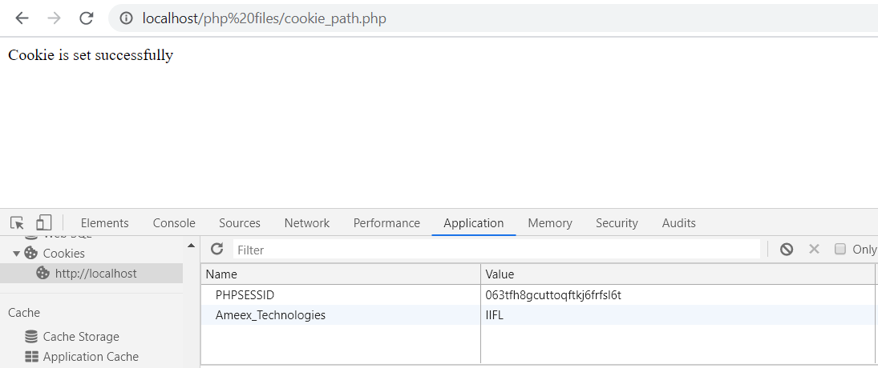

**5.Delete a cookie variable on the last page.**

**1.Cookie creation**

<!DOCTYPE html>

<?php

$cookie_name = "Associate_software_engineer";

$cookie_value = "Drupal";

setcookie($cookie_name, $cookie_value, time() + (86400 * 30),"http://localhost/php%20files/cookie_path.php"); // 86400 = 1 day

echo "Cookie '" . $cookie_name . "' is set!<br>";

echo "Value is: " . $_COOKIE[$cookie_name];

?>

<html>

<body>

**Output:**

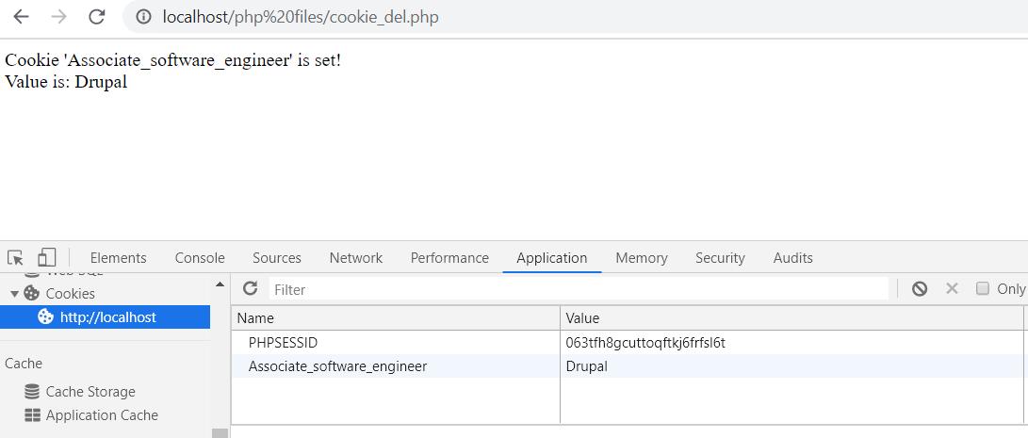

**2.Cookie Deletion**

<!DOCTYPE html>

<?php

setcookie("Associate_software_engineer", "", time() - 7200);

echo"Cookie is now deleted";

?>

**Output:**

